**BI WORKSHOP SCREENSHOTS**

**DATABASE: SQLSERVER, BI TOOL: Tableau**

**Total Sales:  
BI**

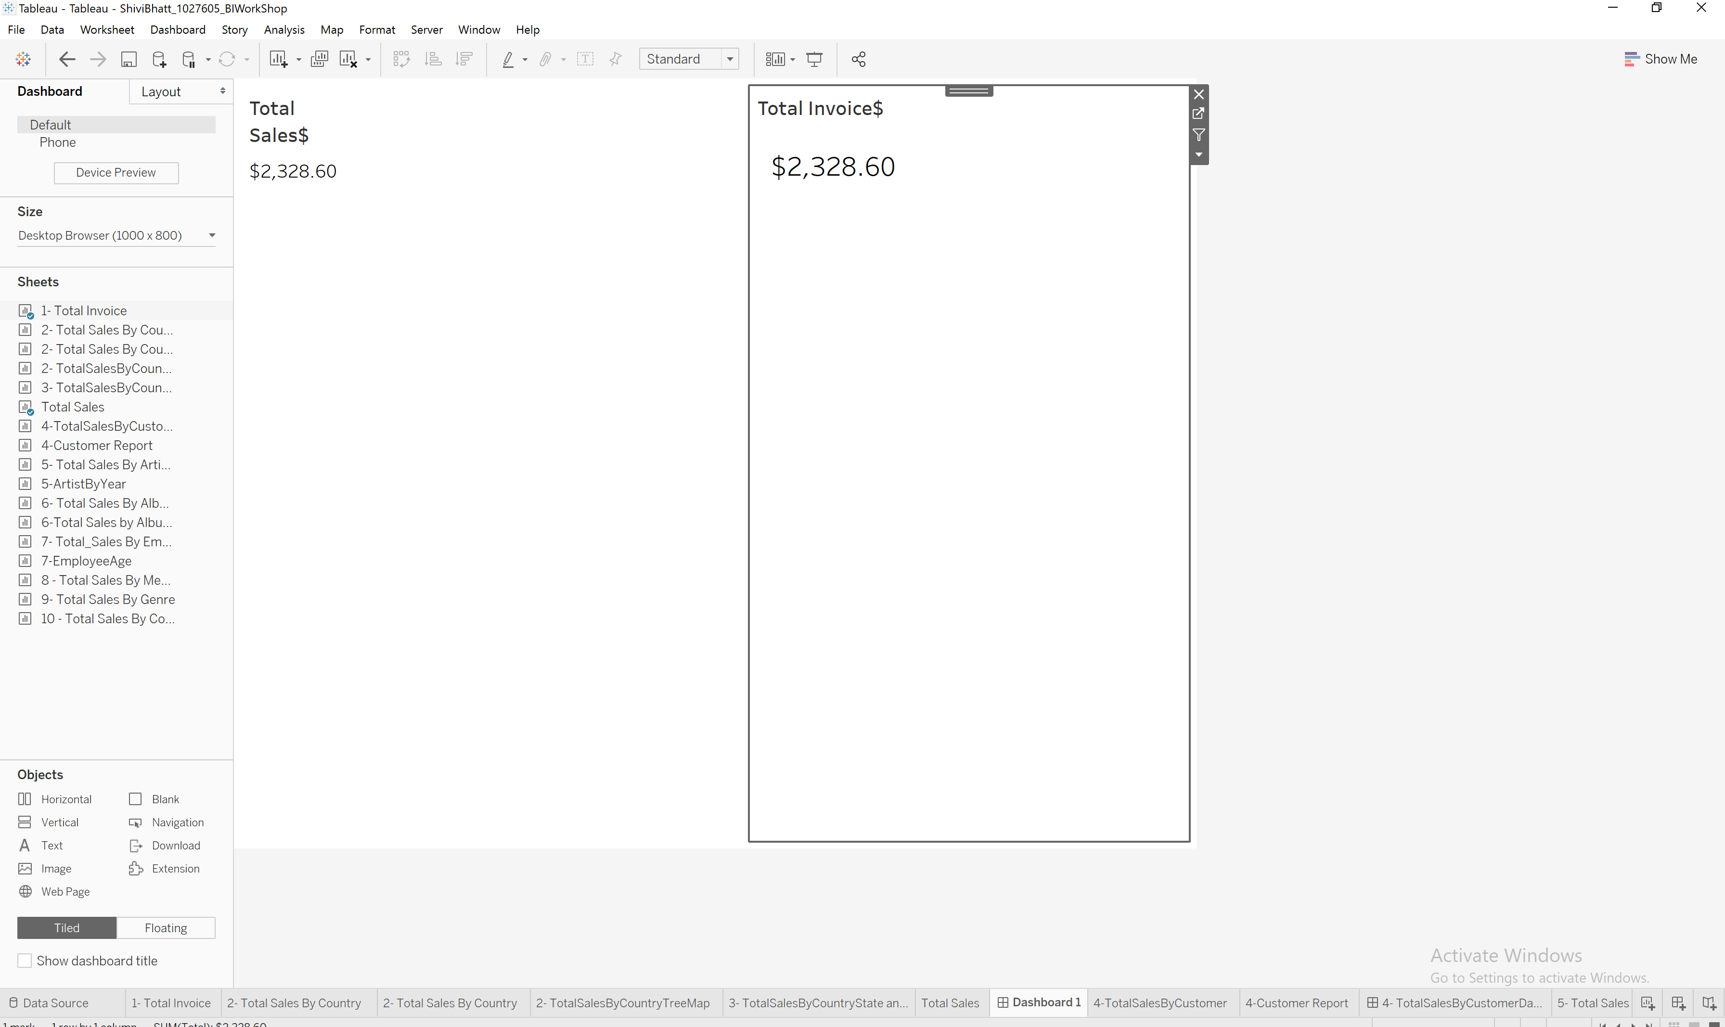

**Query:**SELECT SUM(unitprice * quantity) AS Total_Sales FROM InvoiceLine

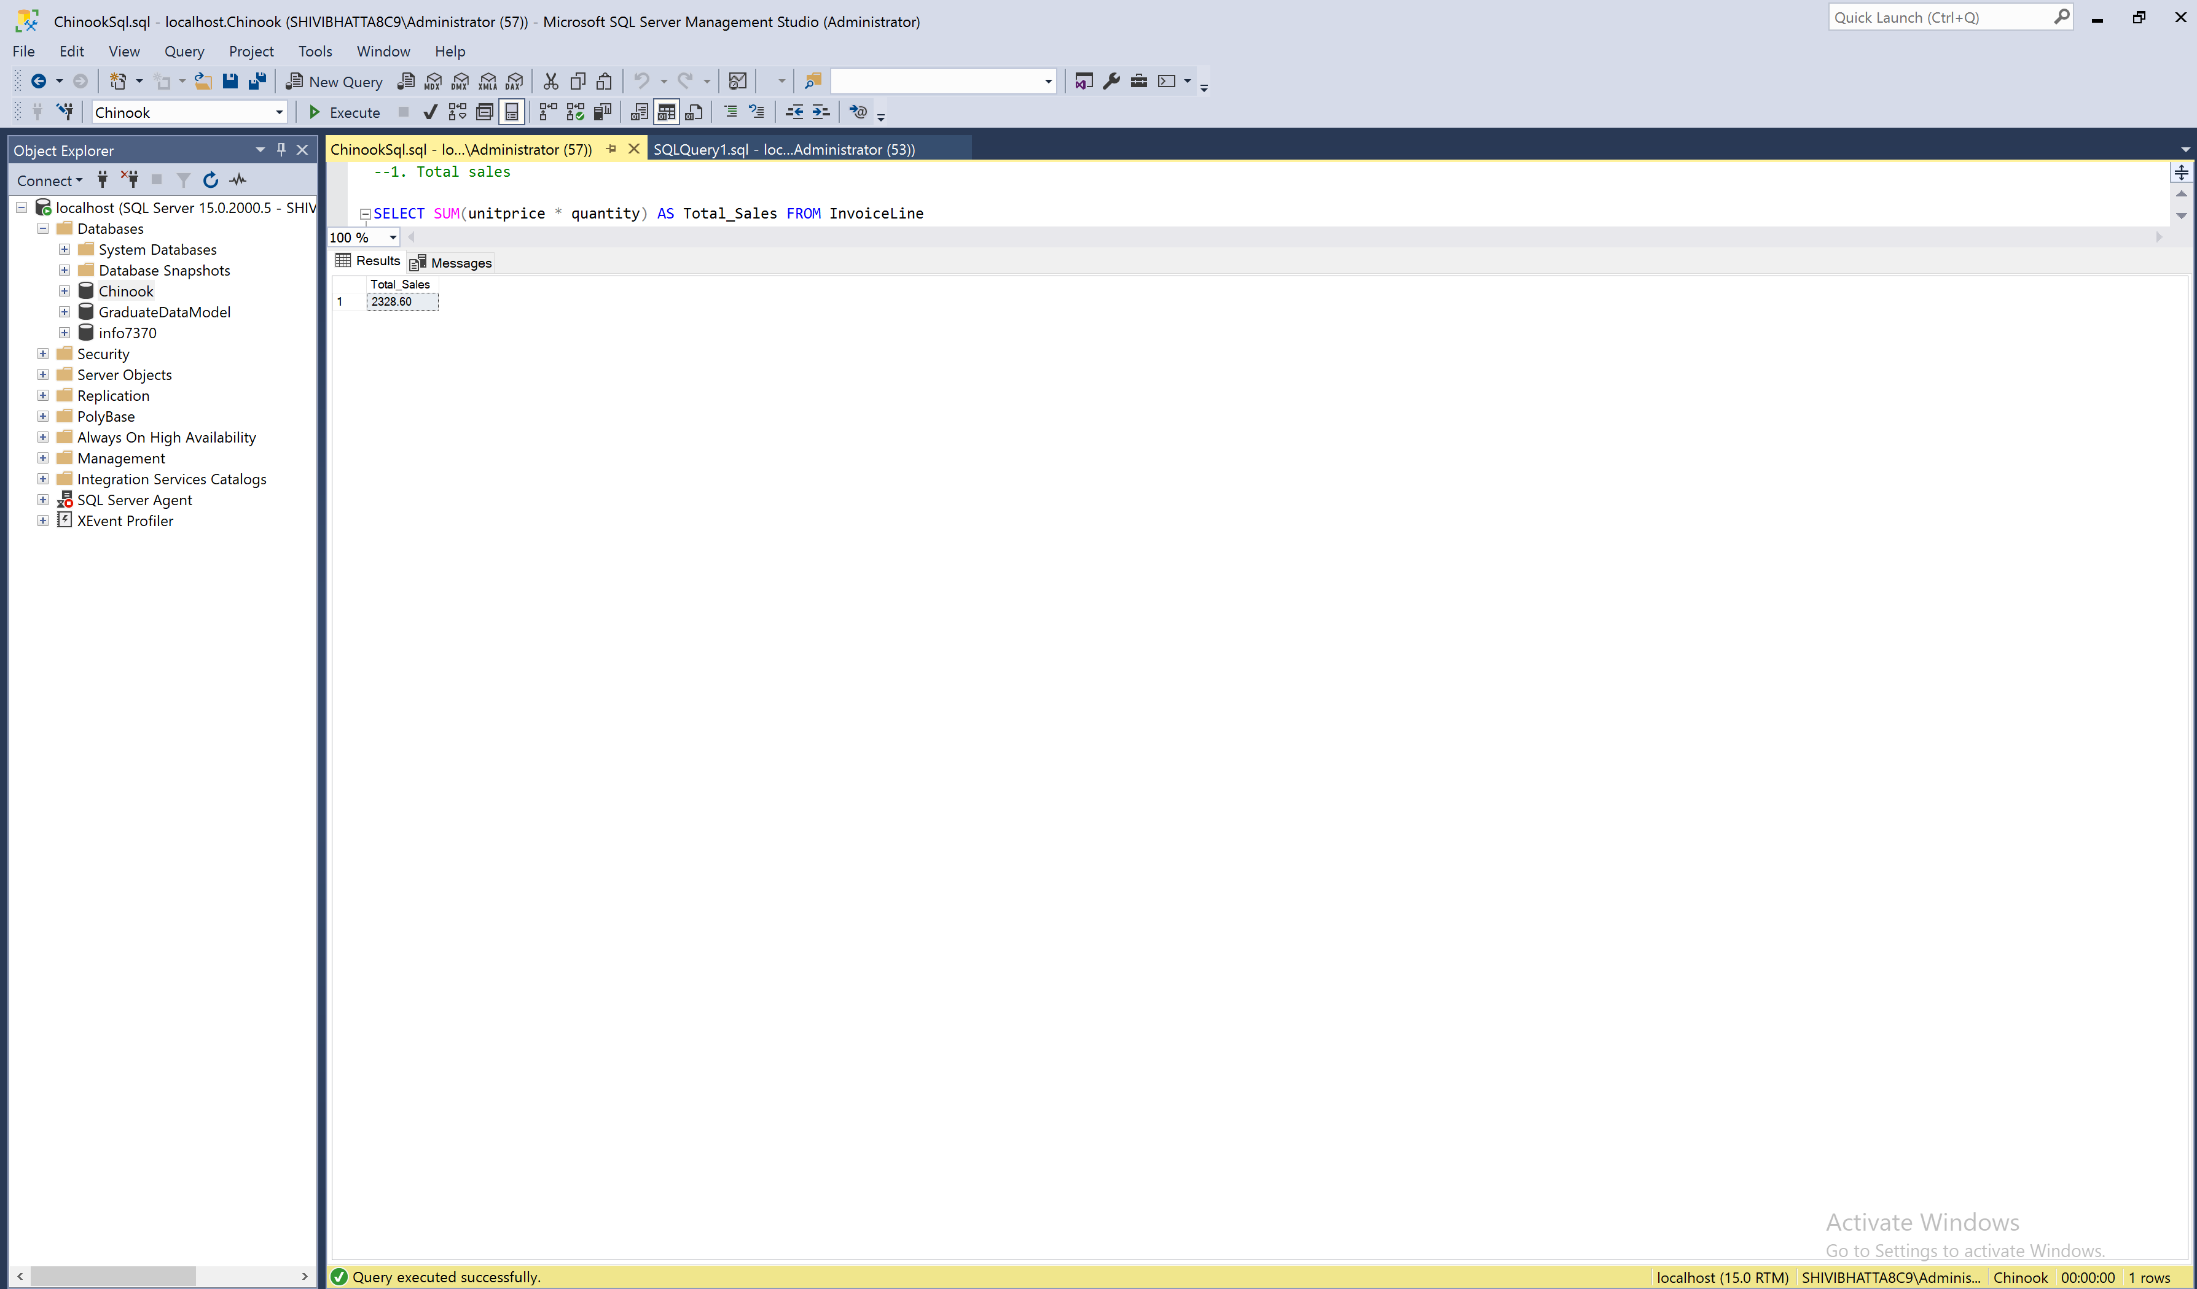

1. Total sales $ by country –ranked (or at least sorted largest to smallest) **BI   
     
   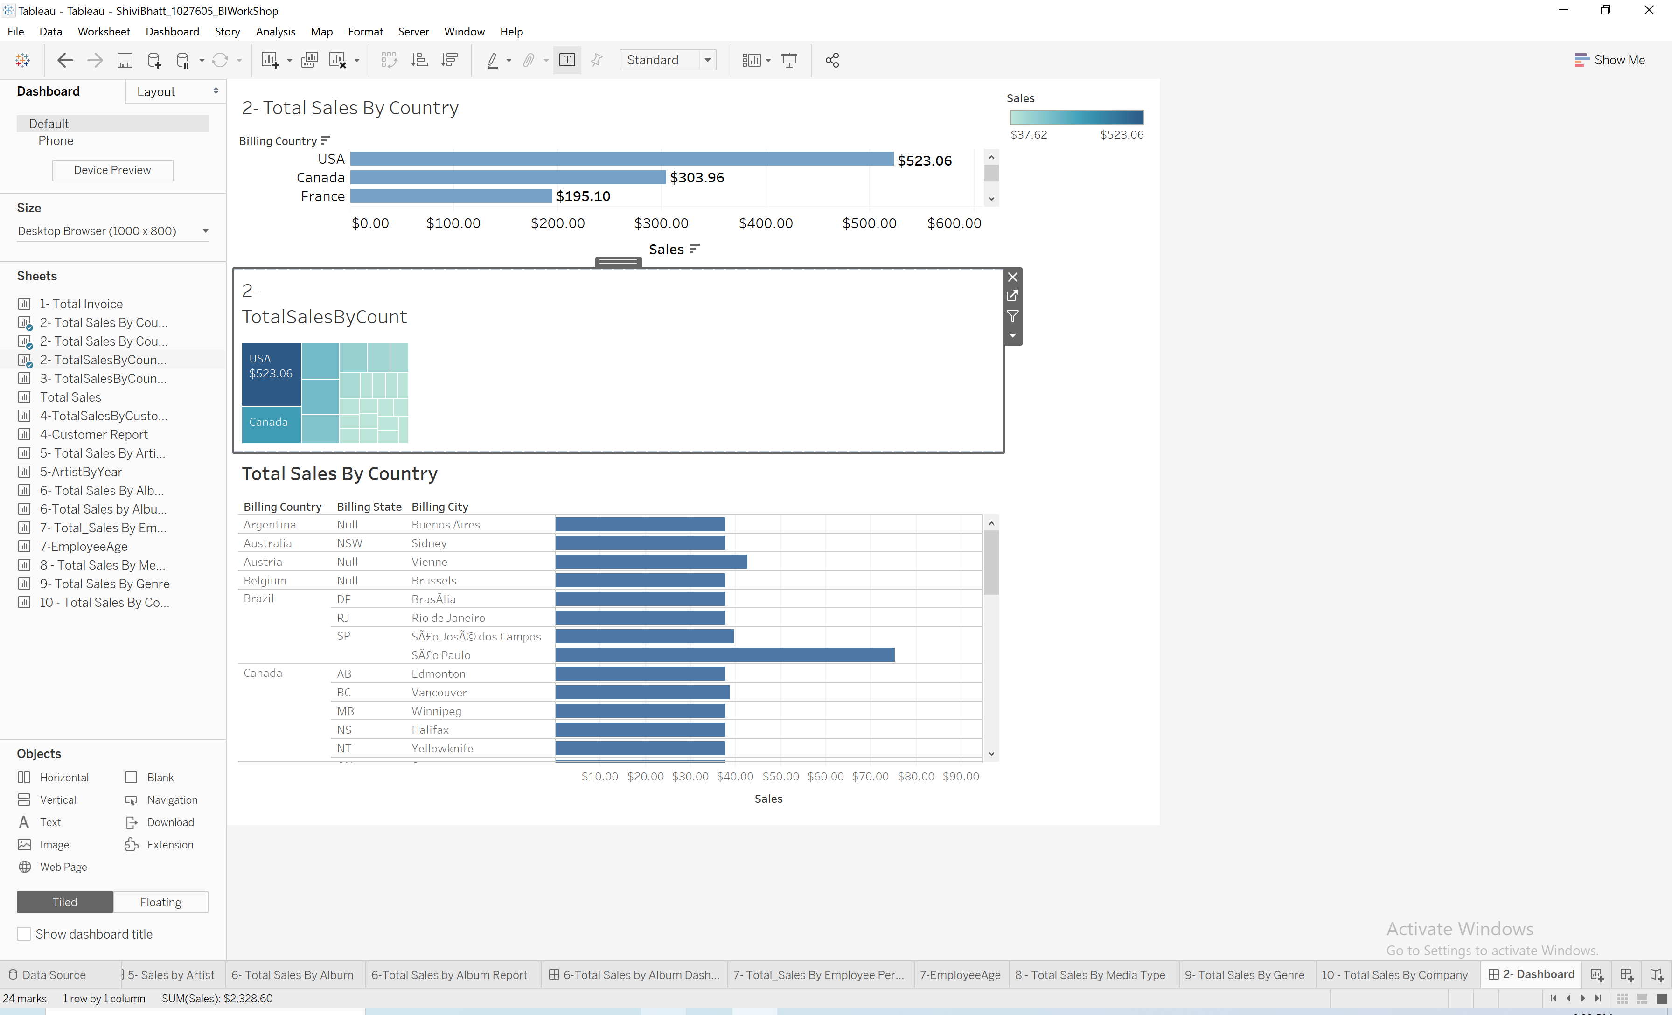**

**Query:**--2. Total sales $ by country –ranked (or at least sorted largest to smallest)

Select Rank() over (ORDER BY SUM(unitprice * quantity) desc) 'Rank',

Invoice.BillingCountry,

SUM(unitprice * quantity) AS Total_Sales

from InvoiceLine

JOIN Invoice on InvoiceLine.InvoiceId = Invoice.InvoiceId

GROUP BY Invoice.BillingCountry

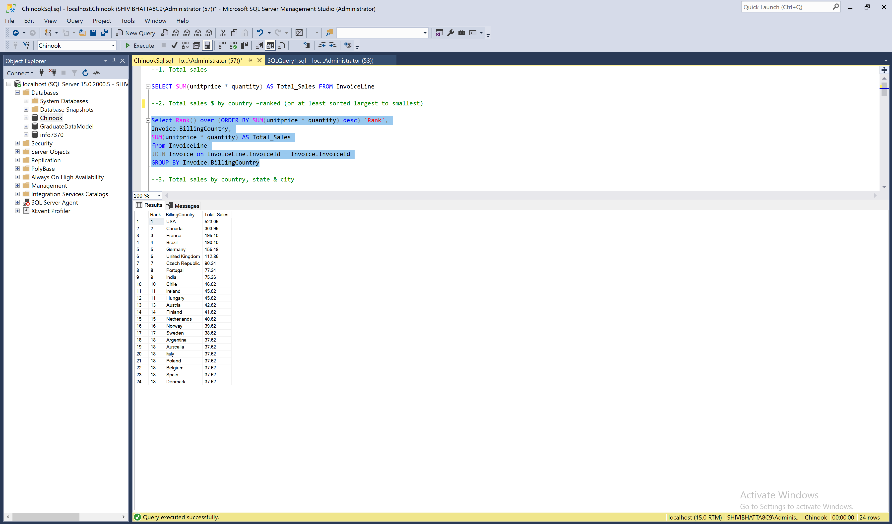

1. Total sales $ by country, state & city

**BI:**

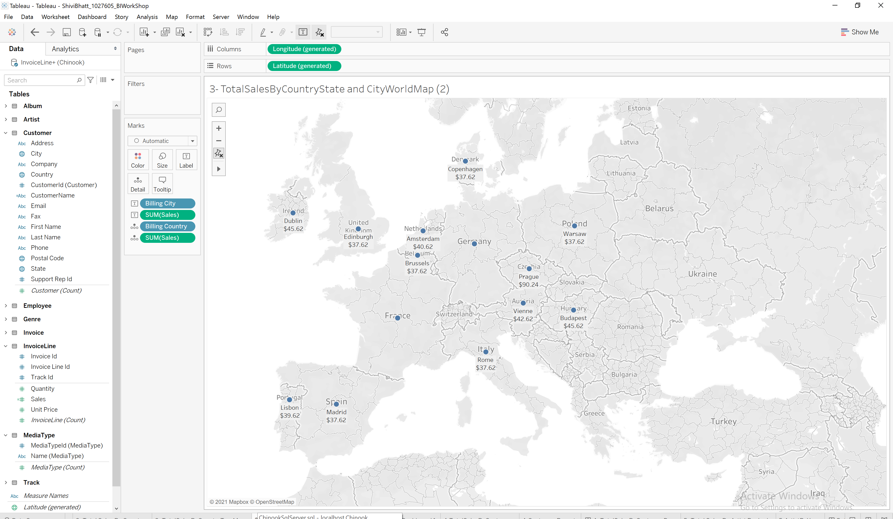

**Query:**

SELECT Invoice.BillingCountry, Invoice.BillingState,

Invoice.BillingCity, SUM(unitprice * quantity) AS Total_Sales

FROM InvoiceLine

JOIN Invoice on InvoiceLine.InvoiceId = Invoice.InvoiceId

where Invoice.BillingState IS NOT NULL

GROUP BY Invoice.BillingCountry, Invoice.BillingState, Invoice.BillingCity

Order by SUM(unitprice * quantity) DESC;

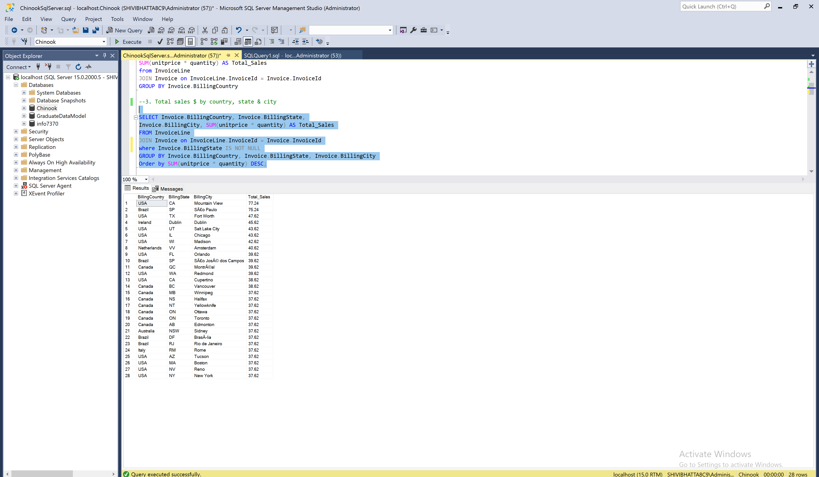

1. **Total sales $ by customer (a person with last name & first name) –ranked (or at least sorted largest to smallest)  
   BI:**

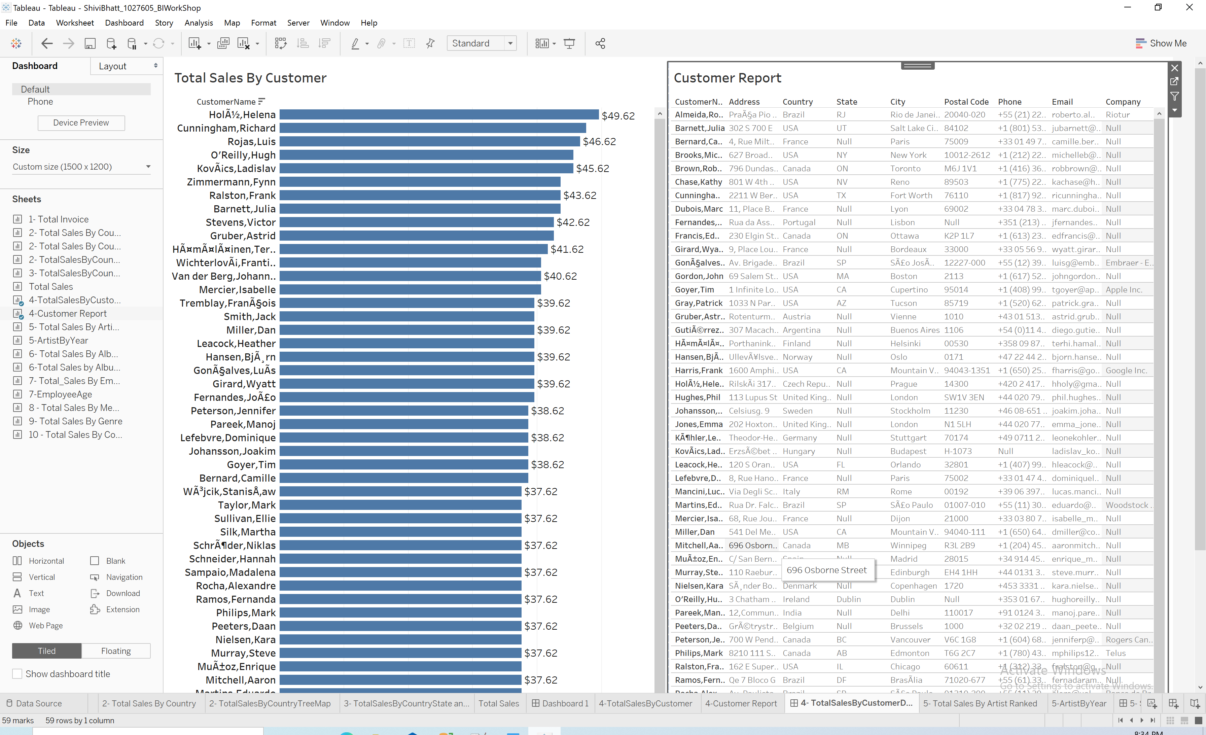

**Query:**

SELECT Rank() over (ORDER BY SUM(unitprice * quantity) desc) 'Rank',

CONCAT(Customer.LastName, ', ', Customer.FirstName) AS Customer_Name,

SUM(unitprice * quantity) AS Sales

FROM InvoiceLine

JOIN Invoice ON InvoiceLine.InvoiceId = Invoice.InvoiceId

JOIN Customer ON Invoice.CustomerId = Customer.CustomerId

GROUP BY CONCAT(Customer.LastName, ', ', Customer.FirstName); 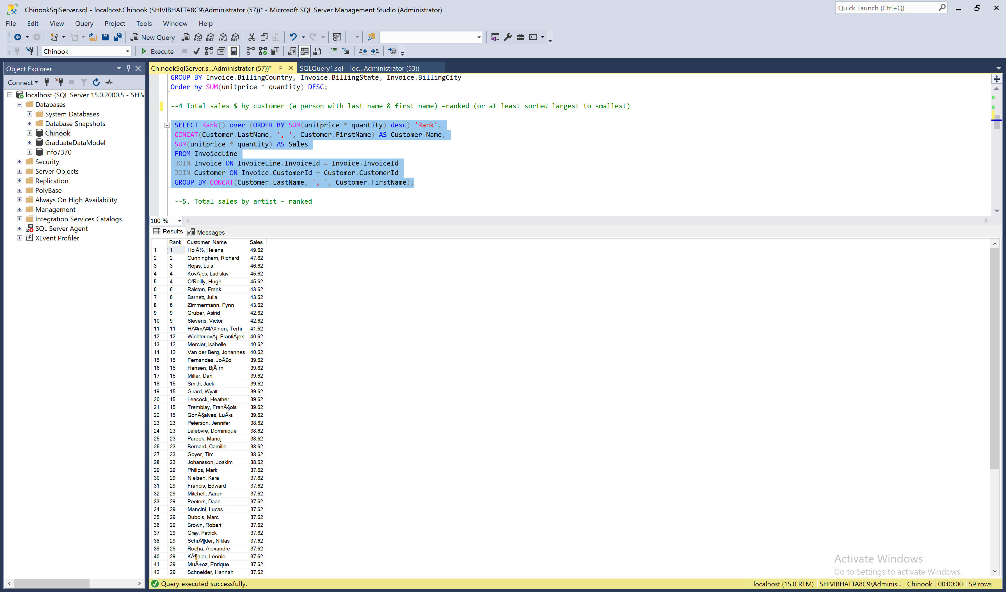

1. **Total sales $ by artist –ranked (or at least sorted largest to smallest)**

**BI:  
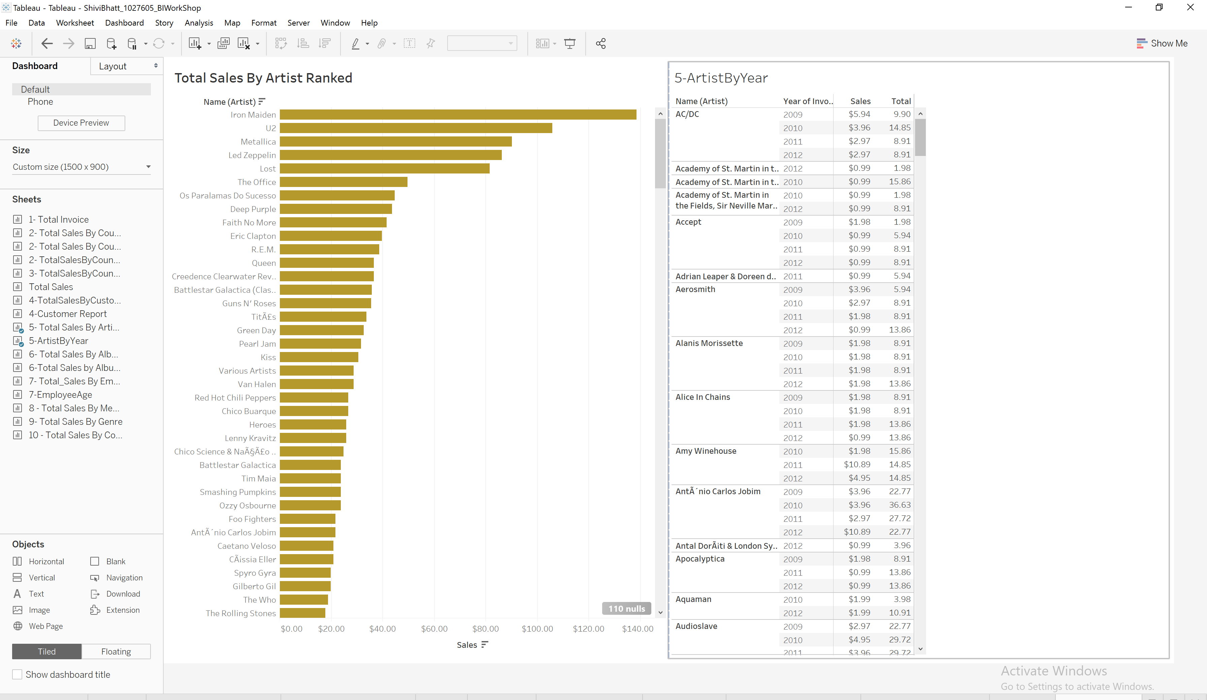**

**Query:**SELECT RANK() over (ORDER BY SUM(Invoiceline.UnitPrice * Quantity) DESC) 'Rank',

Artist.ArtistId, Artist.Name,SUM(Invoiceline.UnitPrice * Quantity) AS Sales

FROM InvoiceLine

JOIN Track ON InvoiceLine.TrackId = Track.TrackId

JOIN Album ON Track.AlbumId = Album.AlbumId

JOIN Artist ON Album.ArtistId = Artist.ArtistId

GROUP BY Artist.ArtistId, Artist.Name 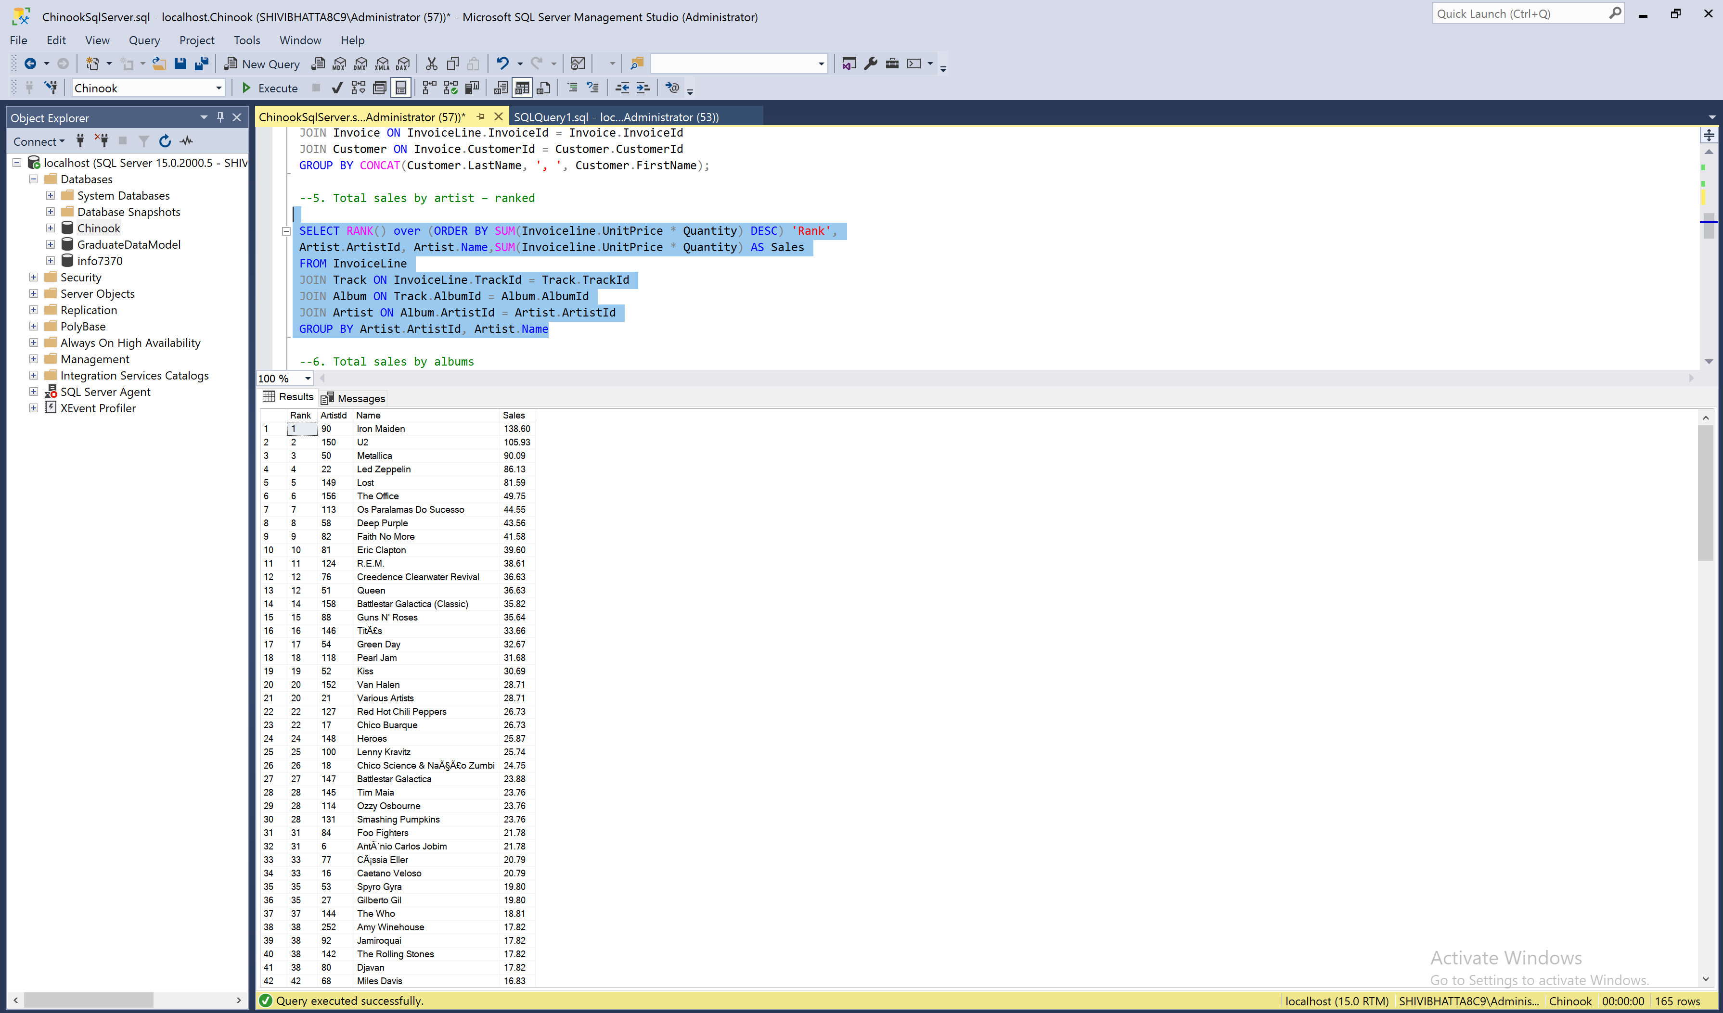

**Query:** SELECT top 10 RANK() over (ORDER BY SUM(Invoiceline.UnitPrice * Quantity) DESC) 'Rank',

Artist.ArtistId, Artist.Name,SUM(Invoiceline.UnitPrice * Quantity) AS Sales

FROM InvoiceLine

JOIN Track ON InvoiceLine.TrackId = Track.TrackId

JOIN Album ON Track.AlbumId = Album.AlbumId

JOIN Artist ON Album.ArtistId = Artist.ArtistId

GROUP BY Artist.ArtistId, Artist.Name  
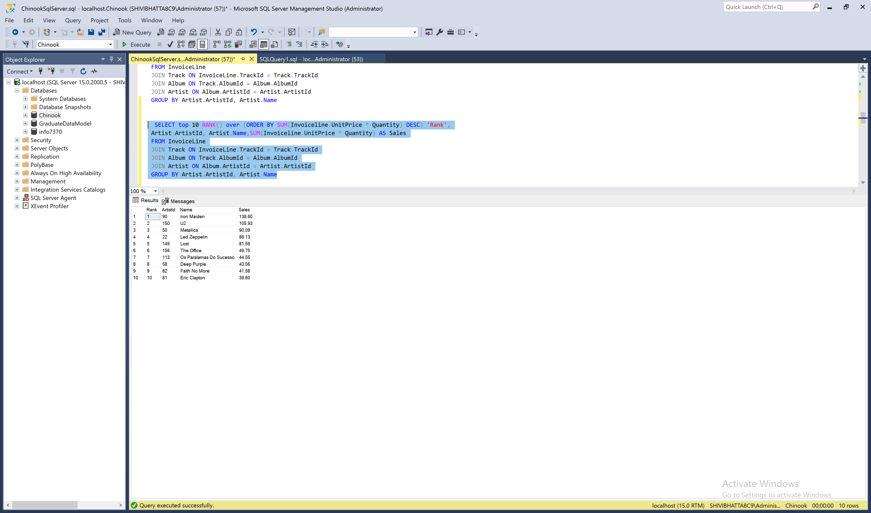

1. **Total sales $ by albums**

**BI:  
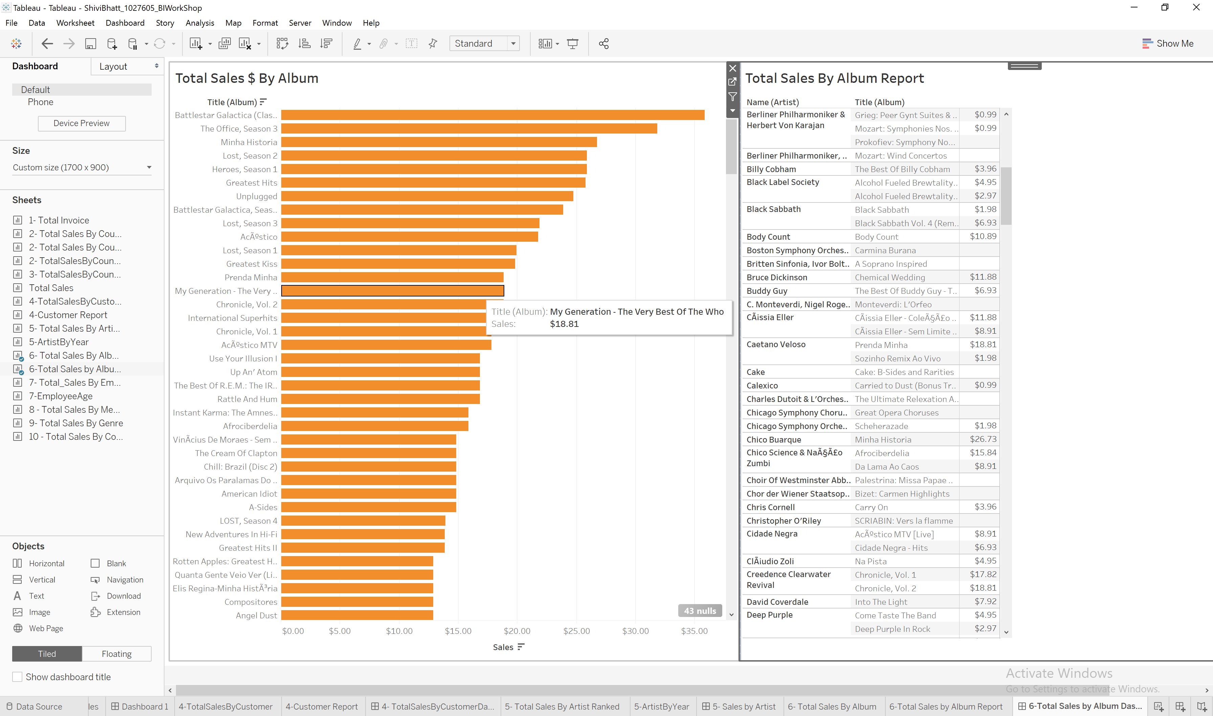**

**Query:**SELECT Album.Title, SUM(Invoiceline.UnitPrice*Quantity) AS Total_Sales

FROM InvoiceLine

JOIN Track ON InvoiceLine.TrackId = Track.TrackId

JOIN Album ON Track.AlbumId = Album.AlbumId

Group BY Album.Title

order by SUM(Invoiceline.UnitPrice*Quantity) desc; 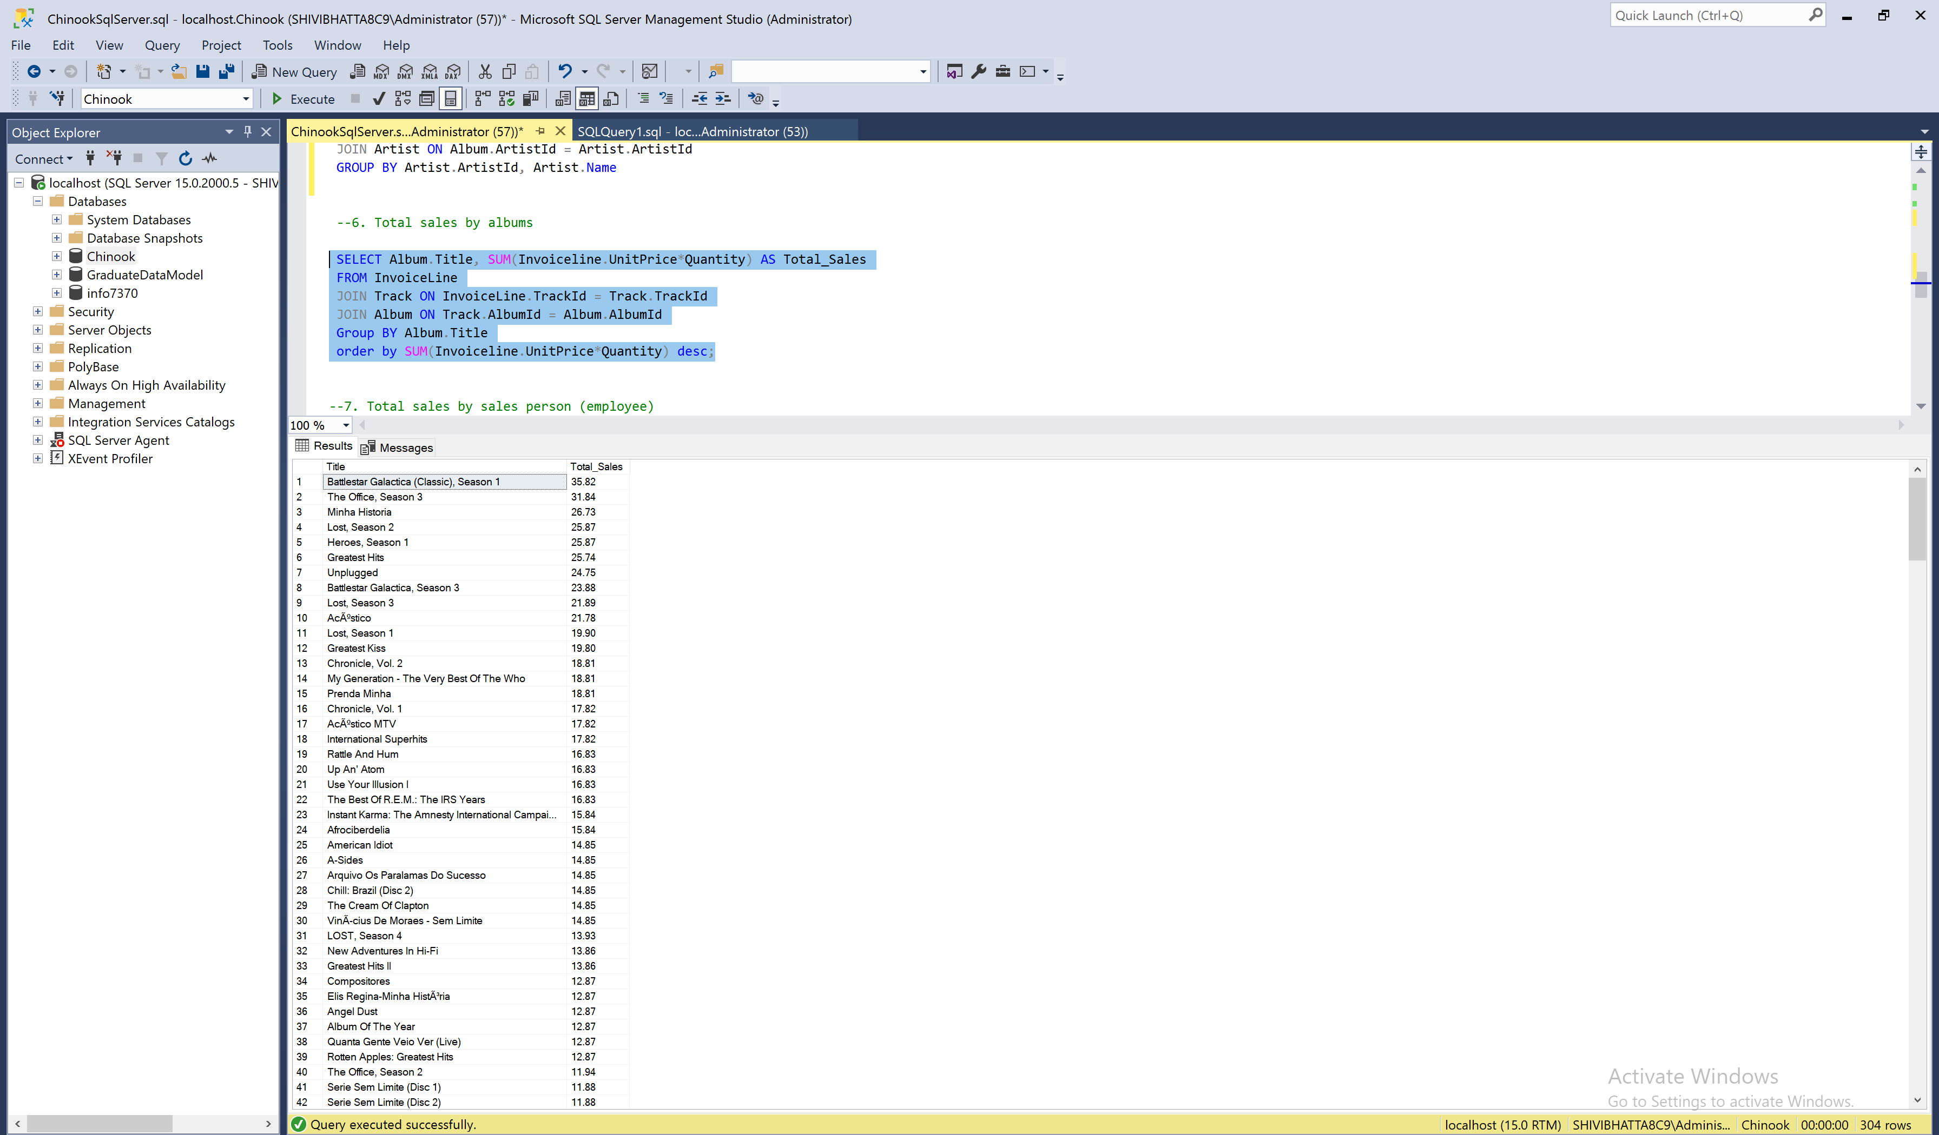

1. **Total sales $ by salesperson (employee)**

**BI:   
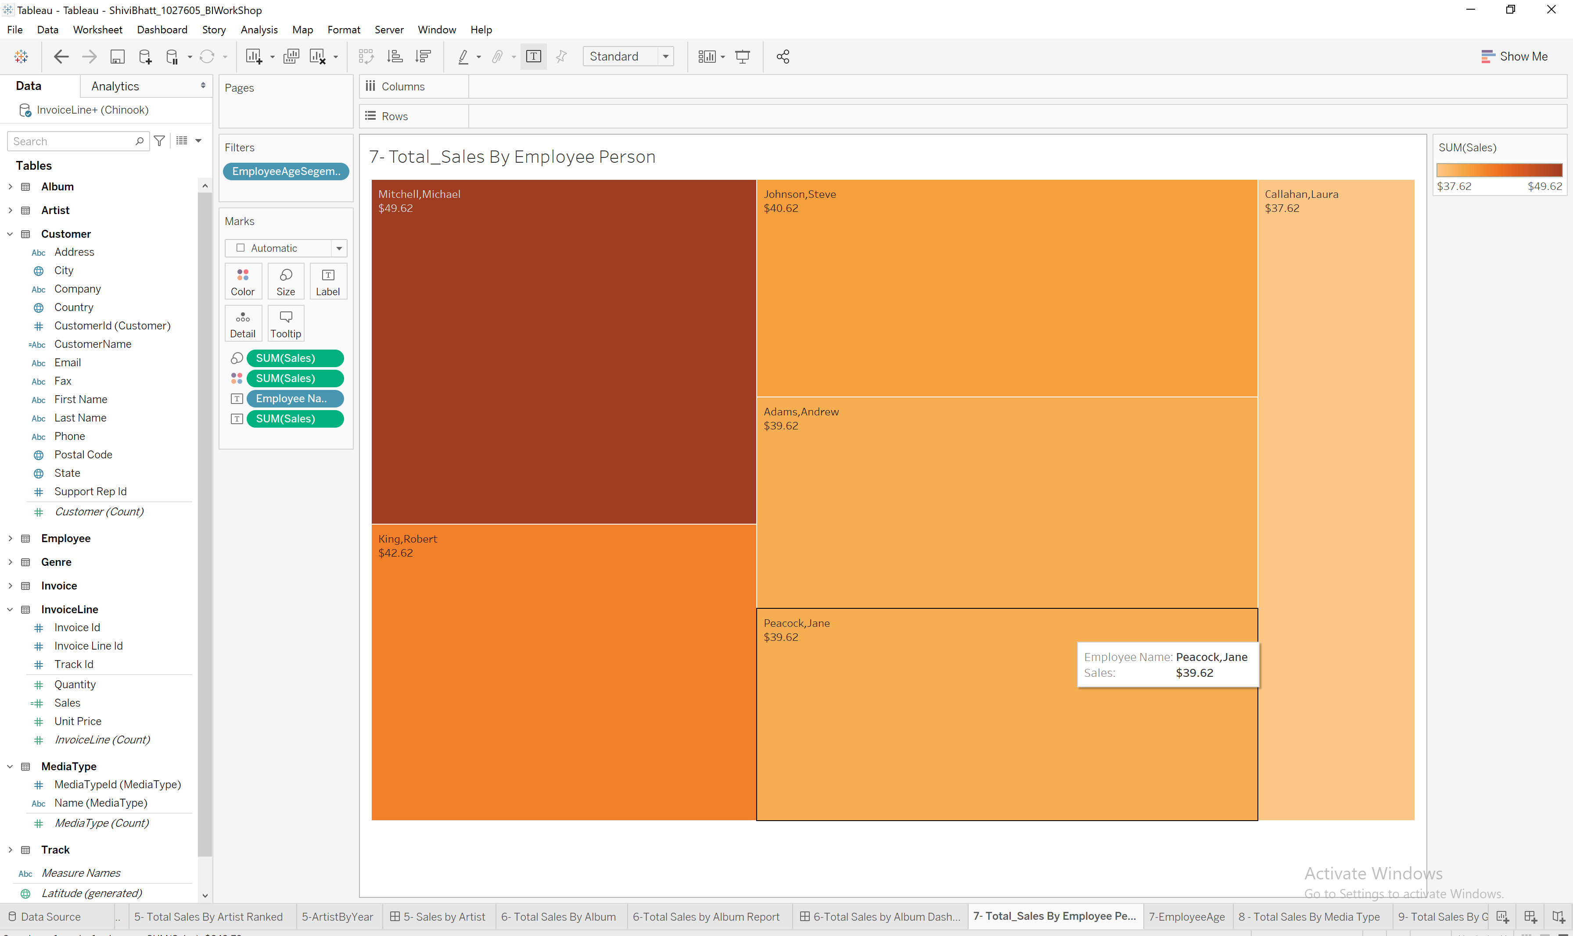**

**Query:**SELECT CONCAT(Employee.LastName, ', ', Employee.FirstName),

SUM(unitprice * quantity) AS Total_Sales

FROM InvoiceLine

JOIN Invoice on InvoiceLine.InvoiceId = Invoice.InvoiceId

JOIN Customer on Invoice.CustomerId = Customer.CustomerId

JOIN Employee ON Customer.SupportRepId = Employee.EmployeeId

GROUP BY CONCAT(Employee.LastName, ', ', Employee.FirstName)

Order by SUM(unitprice * quantity) DESC; 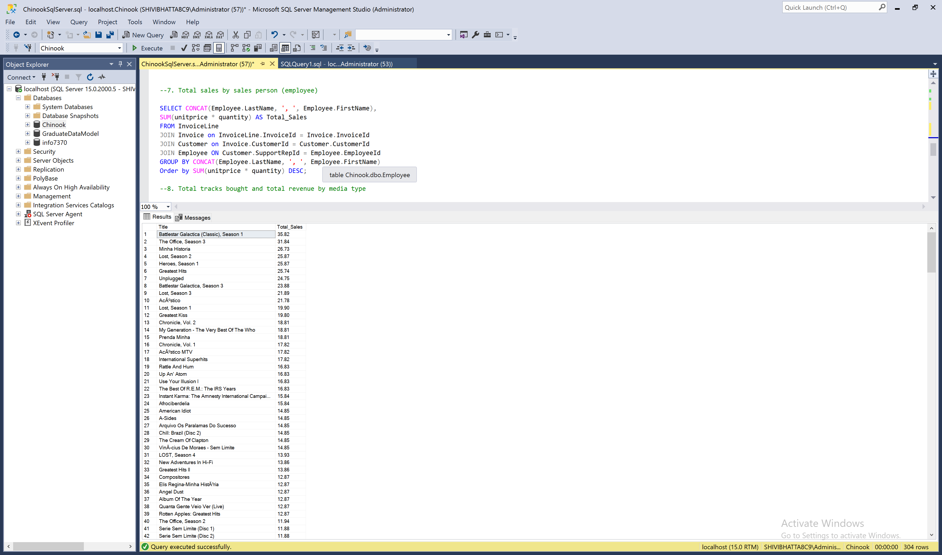

1. **Total tracks bought and total revenue $ by media type  
   BI:**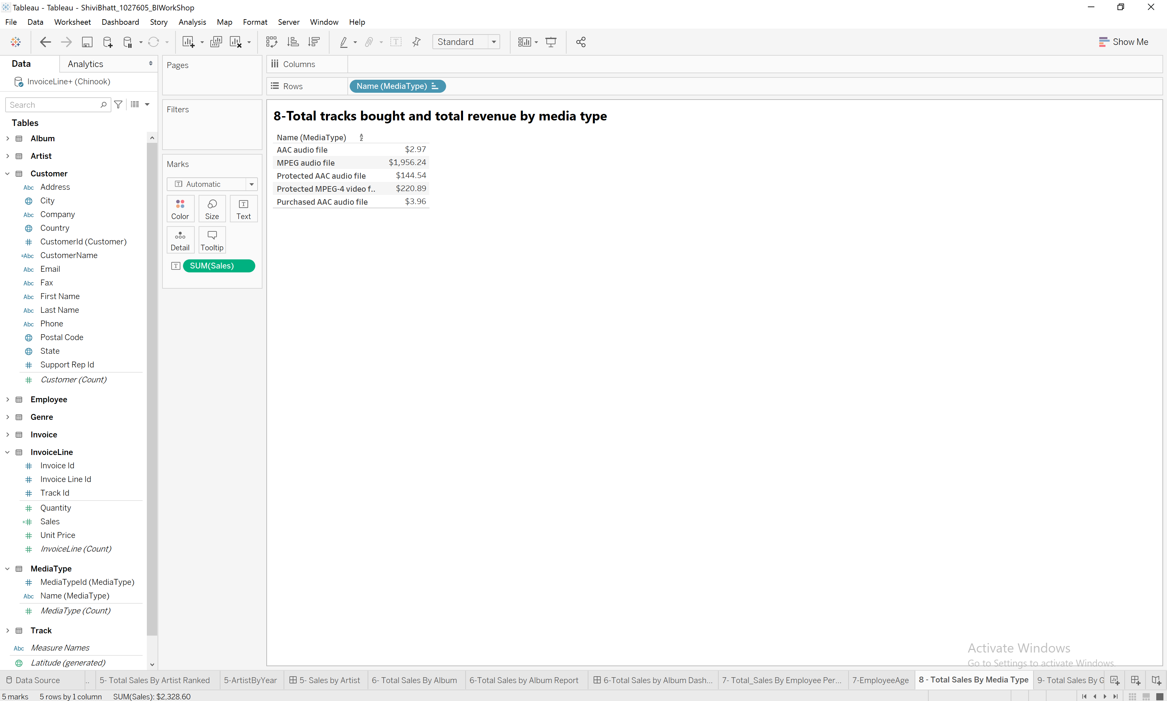

**Query:**SELECT MediaType.Name,SUM(Invoiceline.UnitPrice * quantity) AS Total_Revenue,

SUM(quantity) AS Tracks_Bought

FROM Invoiceline

JOIN Track ON InvoiceLine.TrackId = Track.TrackId

JOIN MediaType ON MediaType.MediaTypeID = Track.MediaTypeID

Group BY MediaType.Name

Order BY SUM(Invoiceline.UnitPrice * quantity) desc;

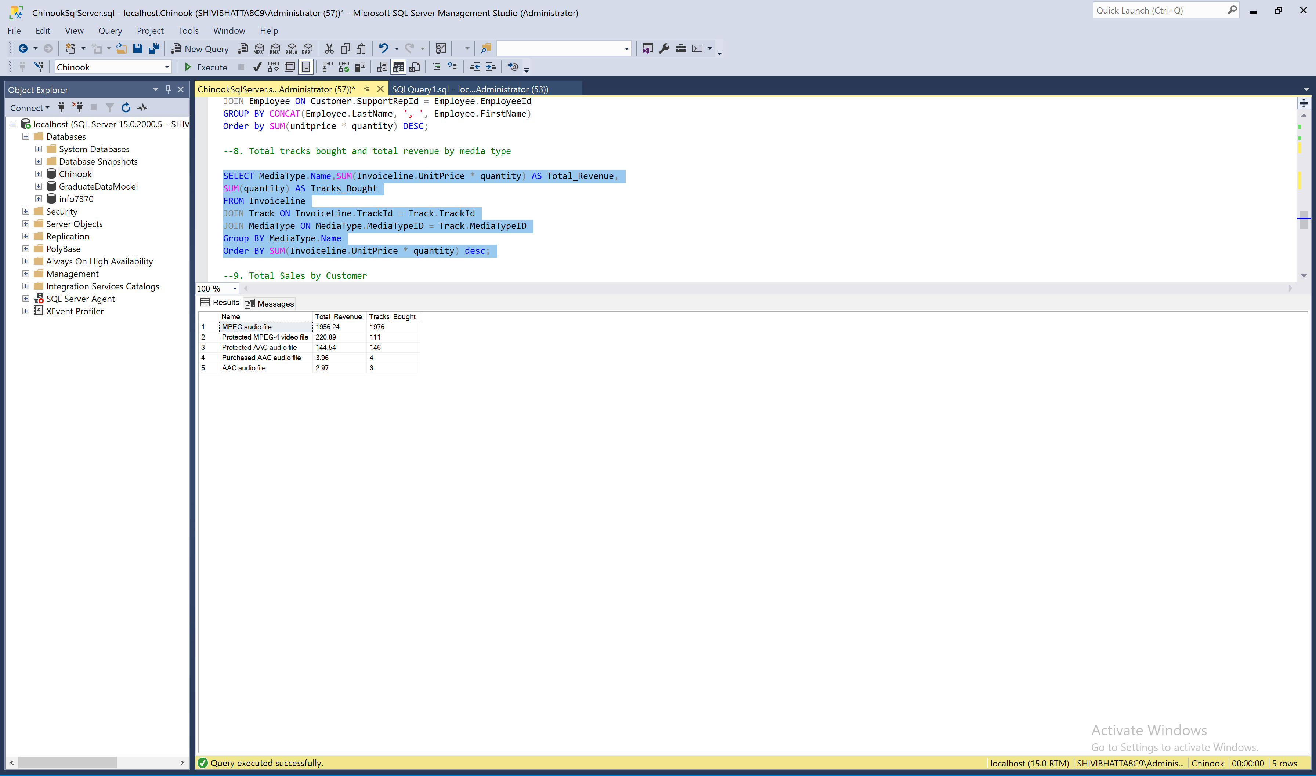

**9 . Total sales $ by genre  
BI:   
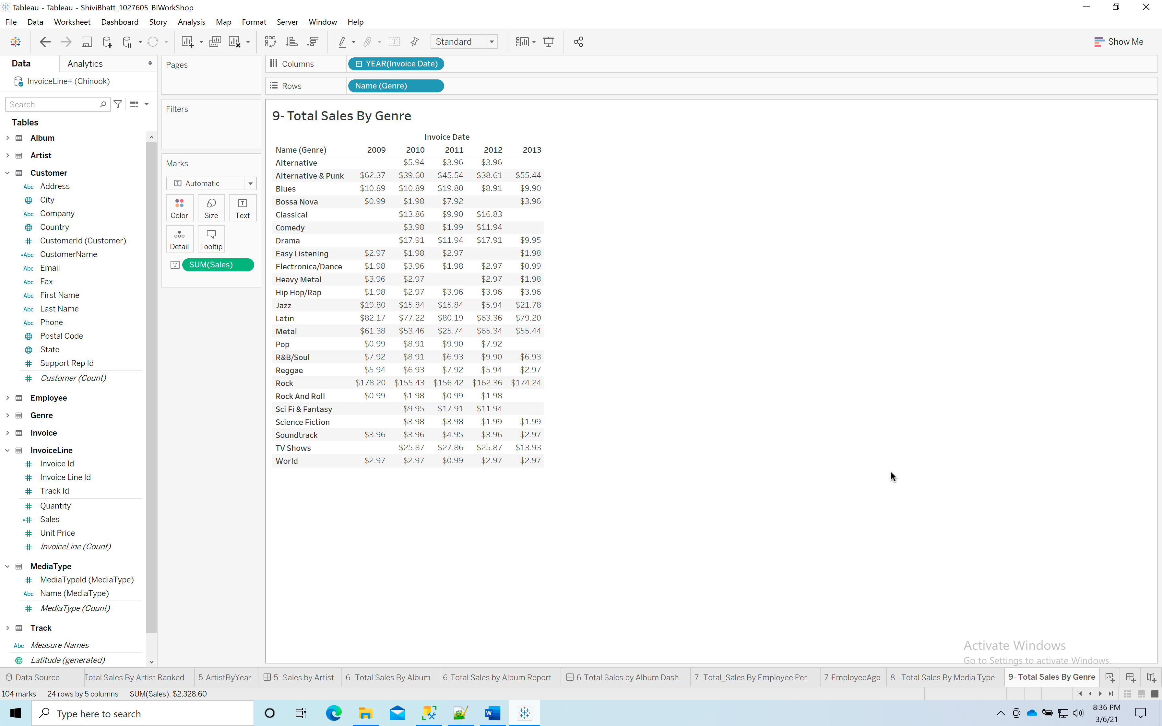  
  
  
Query:**SELECT Genre.Name,SUM(Invoiceline.UnitPrice * quantity) AS Total_Revenue

FROM Invoiceline

JOIN Track ON InvoiceLine.TrackId = Track.TrackId

JOIN Genre ON Genre.GenreId = Track.GenreId

Group BY Genre.Name

Order BY SUM(Invoiceline.UnitPrice * quantity) desc;  
  
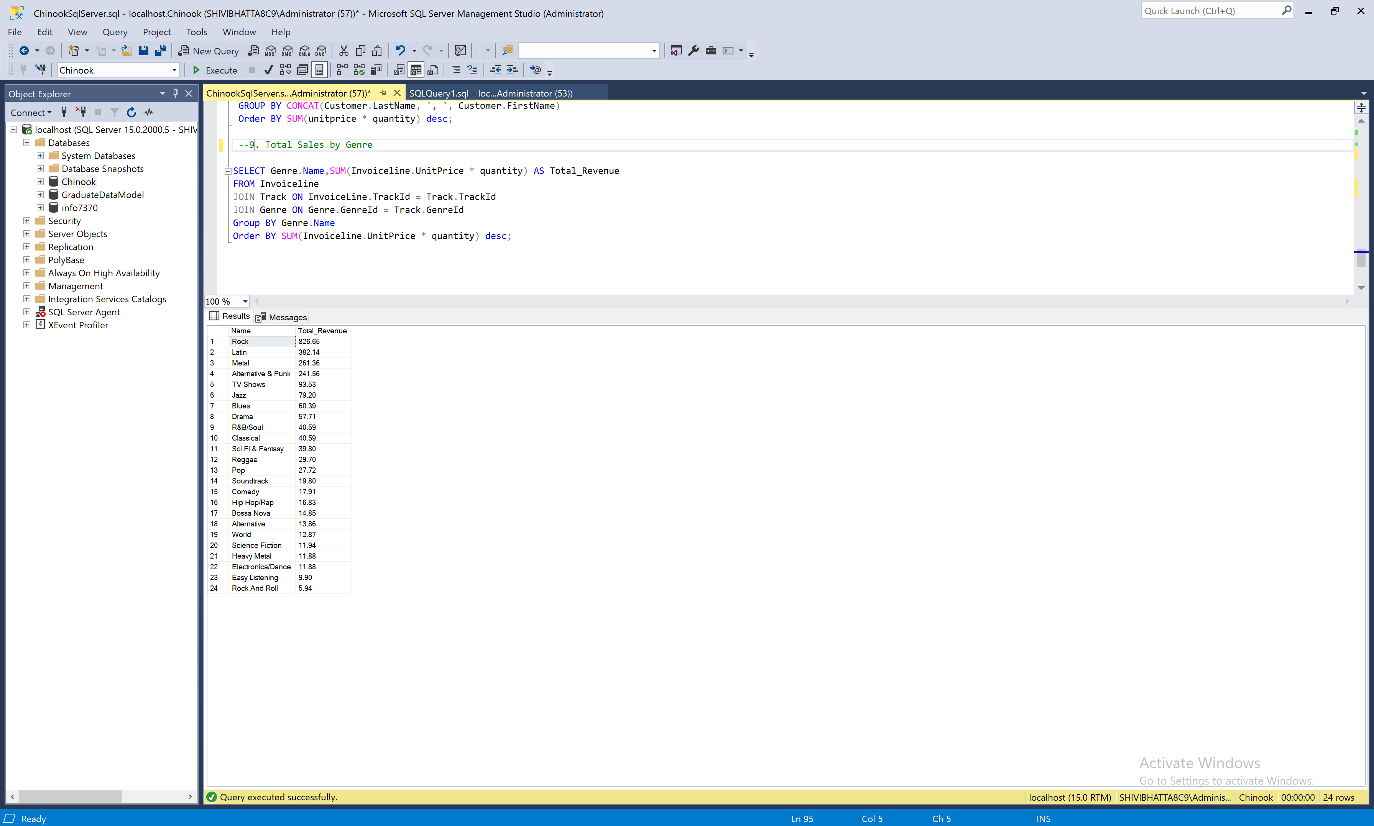

**10. Total sales $ by Company (Customer’s Company)  
BI:**

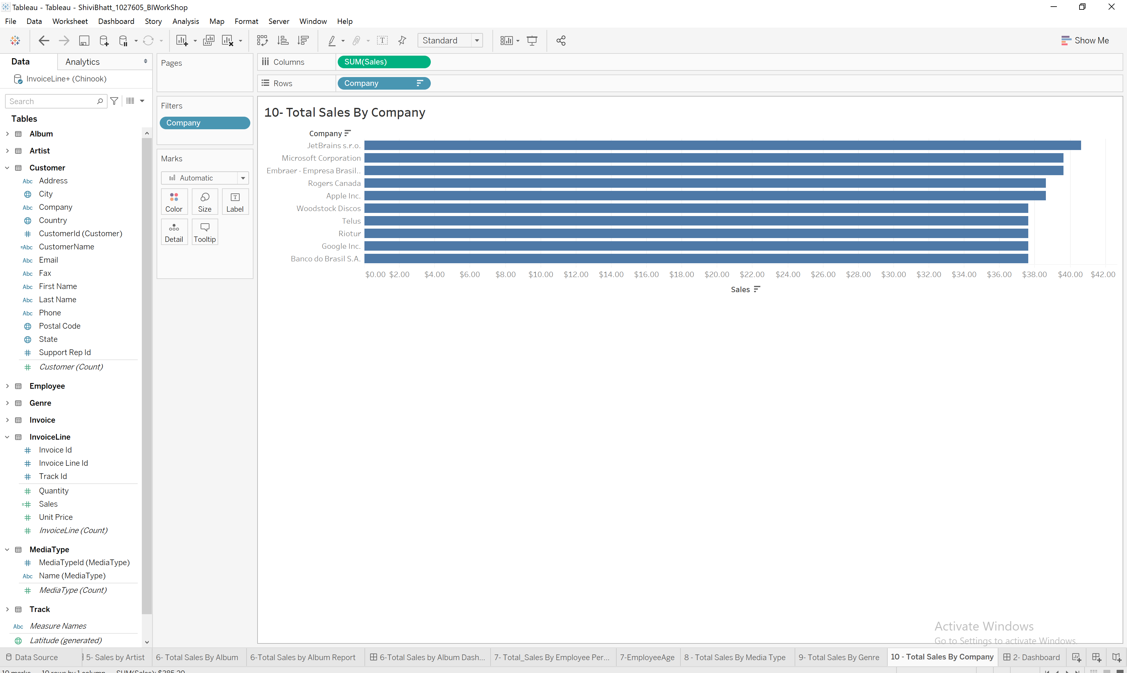

**Query:**SELECT CONCAT(Customer.LastName, ', ', Customer.FirstName) AS Customer_Name, [Company],

SUM(unitprice * quantity) AS Sales

FROM InvoiceLine

JOIN Invoice ON InvoiceLine.InvoiceId = Invoice.InvoiceId

JOIN Customer ON Invoice.CustomerId = Customer.CustomerId

WHERE Company IS NOT NULL

GROUP BY CONCAT(Customer.LastName, ', ', Customer.FirstName), [Company]

Order BY SUM(unitprice * quantity) desc;  


